**Institute of Technology Tralee**

**Ord/Hons BSc. in Computing with Specialism (Group D) - Year 1**

**Continuous Assessment #2**

**Date: 29/11/11**

**Time: 3 – 5 p.m.**

**Introduction to Programming**

**Instructions:** Attempt the following question. You should use the Just BASIC IDE for coding. When you are finished you must print out your code for correction.

**________________________________________________________**

**Q1.**

A Just BASIC program is required that will present the user with the following menu options:

1. Convert Inches to Feet and Inches
2. Convert Metres to Feet
3. Quit

The user can choose any of the options above when the program runs and the main looping process will continue until the user selects option 3, the “Quit” option. You should code the main looping process here using a **do-while** loop.

The choice made by the user (1, 2 or 3) must be validated fully. Any value entered outside of these 3 possibilities must be rejected and the user continually given the chance to re-enter their choice.

Should the user select option 1, then they will be prompted for a quantity in inches. This quantity must be validated fully so that only **whole numbers** are accepted by the program and the value must be **greater than zero**. Should an invalid value be entered, it will be rejected continually until a valid value is supplied. Once a valid value is supplied, the conversion to feet and inches should be performed and the result displayed. Use the fact that there are 12 inches in one foot to help you in your calculations here.

Should the user select option 2, then they will be prompted for a quantity in metres. This quantity must be validated fully so that only **whole numbers or fractional numbers** are accepted by the program and the value must be **greater than zero**. Should an invalid value be entered, it will be rejected continually until a valid value is supplied. Once a valid value is supplied, the conversion to feet should be performed and the result displayed to **2 decimal places**. Use the fact that 1 metre equals 3.281 feet to do the conversion here.

Should the user select option 3, then the main looping process should quit and the user should then be given a farewell message.

You can use **while-wend** loops here for validation purposes and any other structures you wish.

In coding your solution, you should find some or all of the **str$()**, **val()**, **int()**, **asc**(), **mid$**() and **len**() functions to be particularly useful.

Using the test values as indicated in the screen shots below, the program should give you **exactly** the following output when it runs, including banners, blank lines, cleared screens etc.

Also note that there will be a few marks awarded for having a **meaningful comment at the top of the program** and for ensuring that your program **terminates properly** by handing back all the resources it has used to the system on completion.

**Sample Screen Shots**

**In this first iteration of the main loop, the menu option appear and the user is prompted for their choice. As long as the choice entered is not one of the values 1, 2 or 3 , the value will be rejected and the user asked continuously to re-enter until a valid choice is supplied. When a valid choice gets supplied, the screen clears and the next set of actions depend on the user’s choice**

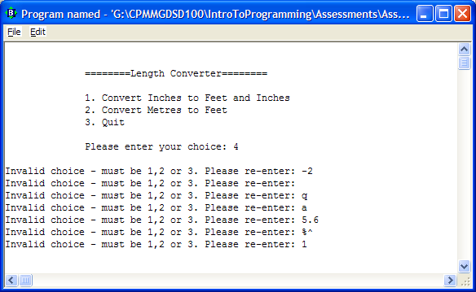

**Once the user hits return after entering the valid choice, the screen clears and, in this case, as the choice was 1, the user is prompted for a length in inches. The user is continually prompted for a valid length until one is supplied. When supplied, the length is inches is converted to feet and inches and displayed. Then the program halts until the user hits return.**

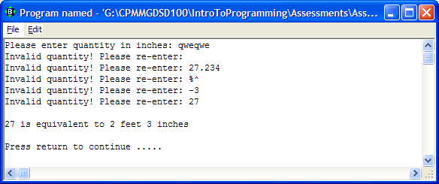

**When the user hits return, the main looping process repeats and the menu options reappear, prompting the user for their choice. This time, 2 is entered as the choice**

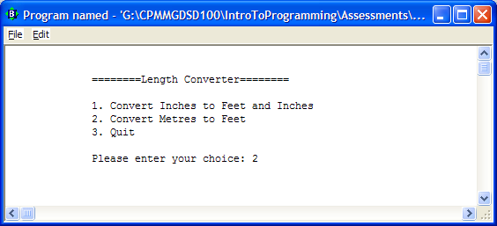

**When the user hits return the screen clears and the user is prompted for a quantity in metres. This is validated until the user enters a valid value. When such a value is entered, it is converted to feet and displayed to 2 decimal places. The program then halts waiting for the user to hit return**

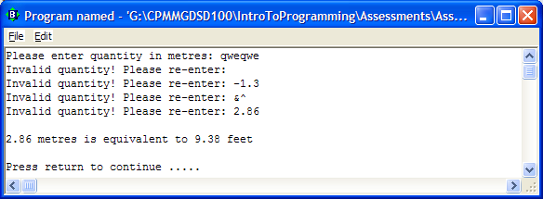

**When the user selects option 3, the quit option the following message appears**

